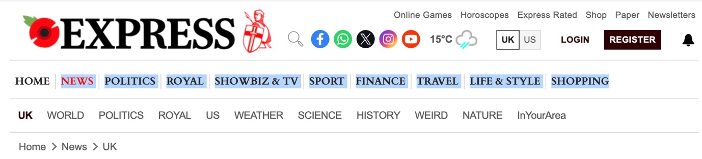The pretty little UK market town where every high street shop and restaurant is open

This town celebrates a rare high street success story as every unit is filled and thriving.
By Aditi Rane, Reporter
08:40, Tue, Nov 4, 2025

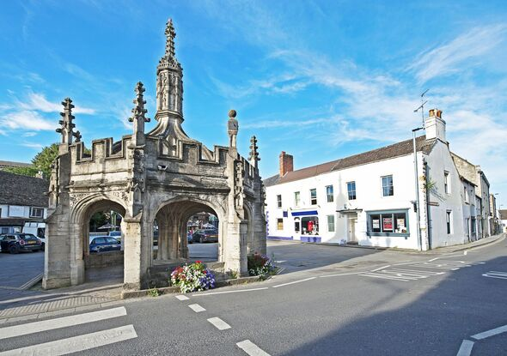
Every shop is Malmesbury is occupied (Image: Getty)

At a time when empty shopfronts and “To Let” signs have become a familiar sight on British high streets, one small town in Wiltshire is proving that local spirit and independent enterprise can still keep a community thriving. For the first time in five years, every single shop and restaurant unit in the centre of Malmesbury is occupied, a milestone that has delighted residents and business owners alike.
On a hill above the River Avon, Malmesbury is one of England’s oldest boroughs, with a history stretching back over a thousand years. Its cobbled streets, honey-coloured stone buildings, and striking 12th-century abbey have long made it a draw for tourists. But in recent years, it’s the town’s bustling high street, lined with family-run boutiques, cafes, and artisan shops, that has captured attention.

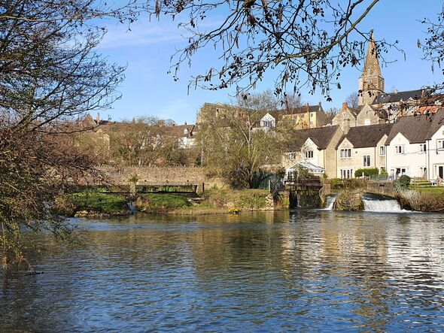
Malmesbury is located on a hill near River Avon (Image: Getty)
David Drake, chair of the Malmesbury Town Team and co-director of a local art gallery with his wife Karen, said the town’s recent success represents an important turning point.
“While other towns of a similar size have seen shops close and units lie empty, we’ve seen year-on-year growth in independent retail and hospitality businesses opening in the town centre,” Mr Drake told the BBC. “They’re run by passionate individuals who call this place home.”
Drake believes the town’s independent spirit is its greatest strength. Rather than relying on national chains, Malmesbury has embraced a mix of local artisans, boutique retailers, and community-led ventures.
The high street features everything from vintage stores and artisan bakeries to eco-friendly refill shops and galleries showcasing local artists.
Recent additions include The Malmesbury Wine Company, Alltype Builder’s Merchant, and Flowers Galore, each bringing something unique to the local offering.
Combined with established favourites like the town’s deli, bookshop, and tearooms, they have helped create a high street that feels vibrant and personal.

The town also benefits from strong community involvement, with local markets, seasonal festivals, and heritage events helping to draw visitors throughout the year.
The Malmesbury Town Team works closely with traders to promote business growth and ensure the town centre remains welcoming and well-kept.

Ends.

