

'Thriving' market town is fully open for business
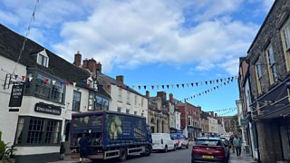
04:48
Malmesbury High Street bucking the trend and flourishing with all shops occupied

By Karen Gardner, Reporting from
Malmesbury and Kirsten Robertson, BBC News, Wiltshire
- Published 31 October 2025
Retailers in a market town say they are bucking the trend with their high street success.
For the first time in five years, all of the shop units and restaurants in the centre of Malmesbury, Wiltshire, are filled and open for business.
David Drake, chair of Malmesbury Town Team and co-director of a local gallery with his wife Karen, said this is an important "milestone" for the town.
He said: "While other towns of a similar size have seen shops close and units lie empty, we have seen a year-on-year growth in independent retail and hospitality businesses opening in the town centre, run by passionate individuals who call this place home."
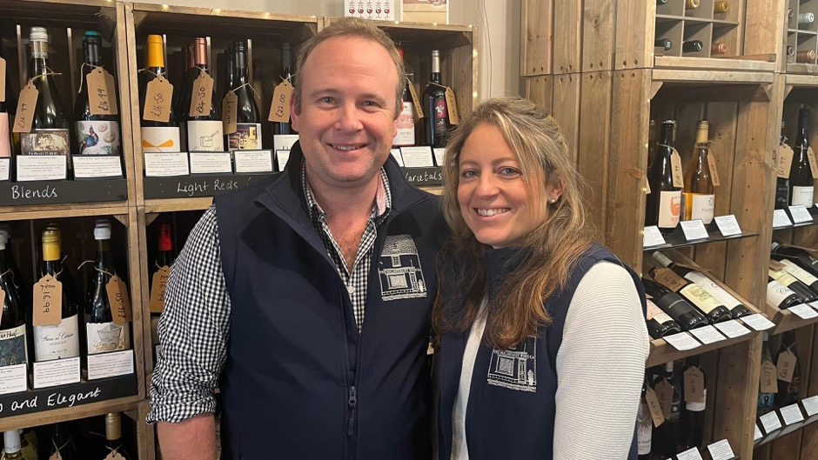
Jamie and Hannah Breeden, owners of The Malmesbury Wine Company

"I think the attraction of Malmesbury is that independent spirit," added Mr Drake.
The latest arrivals on the town's high street include The Malmesbury Wine Company, Alltype Builder's Merchant and Flowers Galore.
Jamie Breeden, of the Malmesbury Wine Company, said trade has been good in their four weeks of operation.
"One thing we felt since we moved here is that there is a real sense of community. There's also also a growing population, with more new build estates on the outskirts of Malmesbury," he explained.

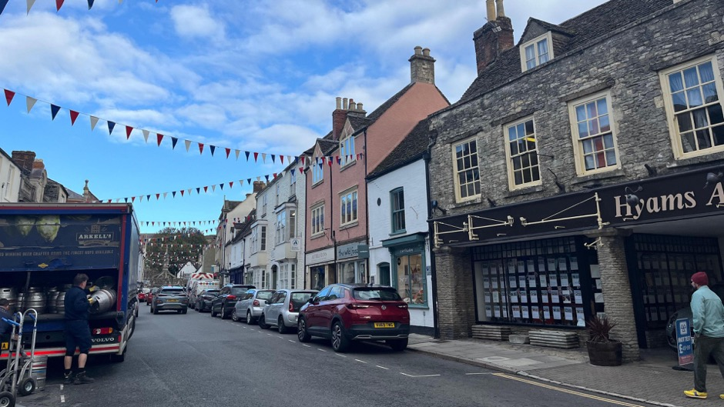

For the first time in five years, all of the shops in Malmesbury are open for business
Jags Bhullar, of Alltype Builder's Merchant, added that the people of Malmesbury have helped create the vibrant high street, adding: "we look forward to opening up in the mornings."
Despite the ample success stories from the town centre, the Malmesbury Town Team are not complacent.
"We're immensely proud of our town and its retail and cultural offer, but businesses need ongoing support and effective promotion," said Mr Drake.
"We want residents and visitors to appreciate there is as much quality and diversity of products and services to be found here on our doorstep as in many of the larger, drive-to urban centres."

